**A Enhancing Patient Tracking and Monitoring in Smart Healthcare : A Machine Learning Approach Using Ultra-Wideband Technology**

Bharath Kumar Reddy Vemireddy

Computer Science and Engineering Department

Lovely Professional University

Panjab, India

[vemireddybharath@lpu.in](mailto:vemireddybharath@lpu.in)

*Abstract:* This paper presents a novel approach to enhance patient tracking and monitoring within Smart Healthcare environments using Ultra-Wideband (UWB) technology and machine learning techniques. The integration of UWB sensors allows for precise indoor localization, overcoming the limitations of traditional tracking methods such as GPS. We collected a comprehensive dataset from UWB sensors deployed in a hospital environment, capturing spatial and temporal information of patient interactions. Three classification algorithms, namely Random Forest Classifier (RFC), Support Vector Classifier (SVC), and K-Nearest Neighbours (KNN) Classifier, were trained on the dataset to evaluate their effectiveness in localizing and tracking patients. Experimental results demonstrate the high accuracy and balanced performance of these algorithms, with RFC achieving 100% accuracy. The proposed approach offers promising advancements in patient tracking and monitoring systems, contributing to improved healthcare delivery and patient outcomes in Smart Healthcare settings.

*Keywords: UWB, Time Difference of Arrival (TDoA), Triangulation, Smart Healthcare, Machine Learning, Precision Localisation*

I. Introduction

The integration of IoT, AI, and advanced medical sensors in high-end medical applications has revolutionized healthcare systems, leading to the emergence of Smart Healthcare. These systems aim to enhance the quality of life by leveraging technology for efficient patient tracking and monitoring within hospital premises. Traditional tracking methods are often inadequate due to their limitations, necessitating the adoption of accurate and precise devices coupled with sophisticated data analysis software.

Indoor localization has emerged as a pivotal area of research, driven by the escalating demand for location-based services in environments where conventional Global Positioning System (GPS) solutions prove inadequate. The convergence of Internet of Things (IoT), Artificial Intelligence (AI), and medical sensors has given rise to the concept of Smart Healthcare, promising elevated standards of patient care and quality of life. Within healthcare facilities, the imperative to track and monitor patient movements is paramount, necessitating precise and efficient localization technologies.

Traditional tracking methods are fraught with limitations, including skeptisim regarding accuracy and scalability, as well as excessive time and labour requirements. As such, there's a pressing need for sophisticated devices capable of accurately locating patients within hospital premises, coupled with robust data analysis software for seamless integration into medical record systems.

Various localization technologies such as WiFi, Bluetooth, RFID, Ultra-Wideband (UWB), and ZigBee offer distinct advantages and constraints. Among these, UWB technology stands out for its sub-meter accuracy, extended range, and resilience to interference, making it particularly suitable for high-precision applications in healthcare settings.

Despite its potential, the full utilization of UWB technology in healthcare remains underexplored. Current tracking systems often rely on costly and less efficient RFID tags, highlighting the untapped capabilities of UWB. Recognizing this, researchers have endeavoured to develop wearable UWB devices integrated with Time-Difference-of-Arrival (TDoA) and triangulation techniques, facilitating real-time patient monitoring and localization within hospital premises.

This paper aims to contribute to the burgeoning field of UWB-based localization by analysing and leveraging UWB datasets to develop advanced models for precise indoor positioning. By harnessing the rich potential of UWB technology, we seek to enhance patient care outcomes, streamline healthcare operations, and pave the way for innovative applications in Smart Healthcare.

The convergence of advanced technologies like UWB with innovative localization techniques holds immense promise for revolutionizing healthcare systems, offering precise patient tracking, monitoring, and localization capabilities essential for enhancing healthcare delivery and patient management.

1.1 Motivation behind the Proposed Work

The inspiration for the work stems from several key factors:

* Advancing Smart Healthcare:

In the context of this paper, the imperative is recognized to elevate healthcare standards through the modernization of patient tracking and monitoring within hospital settings. The introduction of innovative systems aims to streamline patient management processes, thereby minimizing labour and time burdens on healthcare professionals.

* Affordable, Reliable Wearable Devices:

This paper is motivated by the vision of developing cost-effective wearable devices. By harnessing the capabilities of Ultra-Wideband (UWB) technology in conjunction with a variety of sensors customized for specific applications, our goal is to strike a delicate balance between affordability and accuracy. Throughout this paper, we explore the potential of integrating UWB technology with diverse sensor systems to address the challenges of cost-effectiveness while maintaining high levels of precision.

* Software Development for Enhanced Functionality:

Acknowledging the limitations of existing software solutions in ensuring high accuracy and localization, we are compelled to develop sophisticated data analysis software. This software will facilitate real-time tracking and recording of patient movements for future reference.

1.2 Problem Formulation

The bustling environment of hospital premises poses a significant challenge in accurately monitoring the influx and outflow of patients. Current methods, relying on manual record-keeping or basic software, often fall short in precision and efficiency. To address these challenges, we propose a wearable device based on UWB technology, employing TDoA and Triangulation techniques. Our aim is to mitigate errors through advanced filtering methods while maintaining cost efficiency.

1.3 Objectives of this Work

This methodology is designed to achieve the following objectives:

* Patient Tracking: Accurately localize and track patients within hospital premises using UWB technology and TDoA method.
* Patient Navigation: Enable seamless tracking of patient movements from entry points to desired destinations within the hospital.
* Patient Monitoring: Continuously monitor patient whereabouts using sophisticated data analysis software.

II. Literature Review

1. S. Shyam, S. Juliet and K. Ezra, "A UWB System Model for Patient Tracking and Monitoring for Smart Healthcare," 2022 6th International Conference on Devices, Circuits and Systems (ICDCS), Coimbatore, India, 2022, pp. 32-37, doi: 10.1109/ICDCS54290.2022.9780771

This paper presents a UWB-based wearable device for precise patient tracking and monitoring in hospitals. By utilizing UWB technology and TDoA with triangulation, the device achieves accurate 3D localization of patients. Detailed hardware and software architectures, along with component designs, are provided. Initial implementation in a hospital test area is discussed, showcasing the potential for improved hospital management and patient care.

1. Bregar, Klemen. "Indoor UWB Positioning and Position Tracking Data Set." *Scientific Data* *10*, no. 1 (2023): 1-16. Accessed March 27, 2024. <https://doi.org/10.1038/s41597-023-02639-5>.

The paper explores indoor UWB positioning, emphasizing its use for accurate location tracking in environments where GNSS is limited. The dataset provides insights into refining positioning algorithms, contributing to advancements in various sectors like healthcare and commerce.

1. Nosrati, Leyla, Mohammad Sadegh Fazel, and Mohammad Ghavami. "Improving indoor localization using mobile UWB sensor and deep neural networks." IEEE Access 10 (2022): 20420-20431.

<https://ieeexplore.ieee.org/stamp/stamp.jsp?arnumber=9713894>

The study introduces a novel approach to indoor localization using a mobile UWB sensor, improving ranging accuracy without line-of-sight connections. Machine and deep learning algorithms enhance position estimation, with simulation results demonstrating significant performance improvements.

1. Bocus, Mohammud J., and Robert Piechocki. "A Comprehensive Ultra-Wideband Dataset for Non-cooperative Contextual Sensing." *Scientific Data* *9*, no. 1 (2022): 1-13. Accessed March 27, 2024.

<https://doi.org/10.1038/s41597-022-01776-7>.

A comprehensive dataset for passive localization and activity recognition using UWB technology in a real residential environment is detailed. Ethical considerations were prioritized, and the dataset allows for robust analysis of non-cooperative localization and activity recognition.

1. Han, Taekjin, Wonho Kang, and Gyunghyun Choi. 2020. "IR-UWB Sensor Based Fall Detection Method Using CNN Algorithm" Sensors 20, no. 20: 5948. <https://doi.org/10.3390/s20205948>

The research presents a fall detection system using IR-UWB radar sensor data and CNN algorithm, achieving high accuracy and preserving user privacy. Challenges like data imbalance are addressed, suggesting improvements through techniques like LSTM networks.

1. Qi, Fugui, Fulai Liang, Miao Liu, Hao Lv, Pengfei Wang, Huijun Xue, and Jianqi Wang. "Position-information-indexed classifier for improved through-wall detection and classification of human activities using UWB bio-radar." IEEE antennas and wireless propagation letters 18, no. 3 (2019): 437-441.

A position-information-indexed classifier (PIIC) is proposed to enhance human activity classification using UWB bio-radars. By utilizing position data and modularized databases, PIIC outperforms traditional classifiers, promising applications in search-and-rescue and military missions.

III. Methodology

3.1 Patient Tracking

Patient tracking involves tracing and monitoring using specialized software. This section outlines the architectural framework and experimental setup for tracking patient locations within hospital premises, employing a triangulation technique.

3.1.1 Architectural Overview

The proposed architecture comprises anchors, tags, routers, and a Power over Ethernet (PoE) switch. Anchors, fixed to walls, establish communication with wearable UWB tags worn by patients. These tags emit regular pulses received by synchronized anchors. The nearest anchor to a tag is designated as the master anchor, responsible for relaying pulse timing information to other anchors and the PoE switch. The system adopts the Time Difference of Arrival (TDoA) method and utilizes TCP/IP transmission protocol. A minimum of four anchors are essential for accurate localization. Data packets are transmitted via PoE cables to a central server. Geometric calculations are performed on the server, and patient coordinates are relayed to data analysis software accessible through web or mobile applications. Additionally, a router is integrated to extend the system's coverage via WiFi.

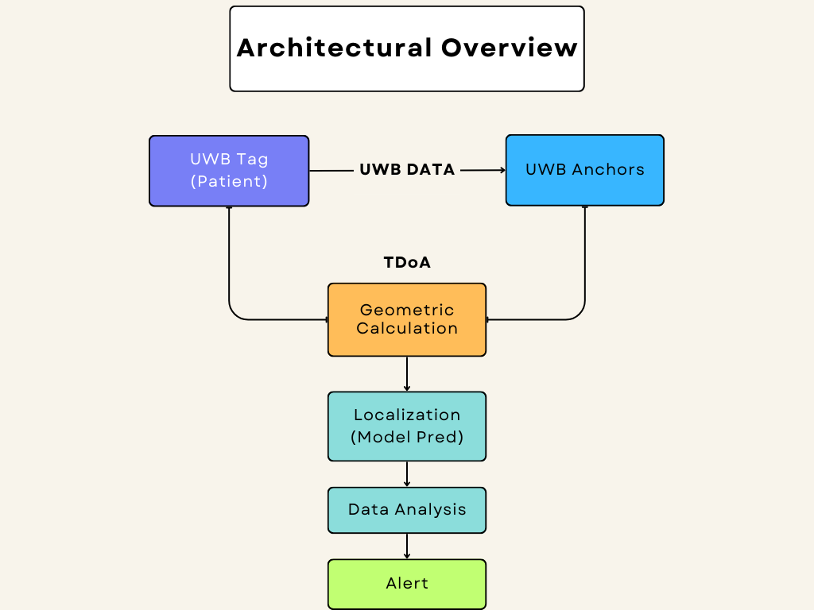

Flowchart 1: Architectural Overview

3.1.2 Test Bed Setup

The proposed system undergoes implementation and testing in two phases. The initial phase involves testing within a controlled environment. Anchors and tags are deployed to evaluate system performance under various conditions, including line of sight and non-line of sight scenarios. The second phase extends the system to cover the entire hospital premises, with plans to install anchors strategically for comprehensive patient tracking.

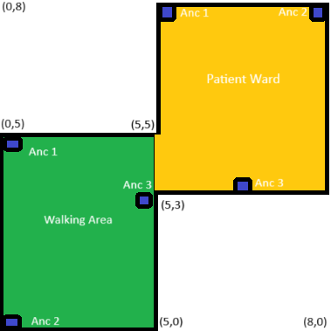

Picture 1: Test Bed Setup

3.1.3 Triangulation Technique

In indoor localization systems, triangulation is a key method used to find the exact position of a person or object within a building. Think of it like using multiple landmarks to pinpoint your location on a map. There are different ways to do this, but one common method is called Time Difference of Arrival (TDoA).

TDoA works by measuring how long it takes for a signal to travel from the person or object to different reference points, called anchors, placed around the building. These signals can be things like radio waves or sound waves. By comparing the arrival times of these signals at different anchors, we can figure out the differences in the time it takes for the signal to reach each anchor.

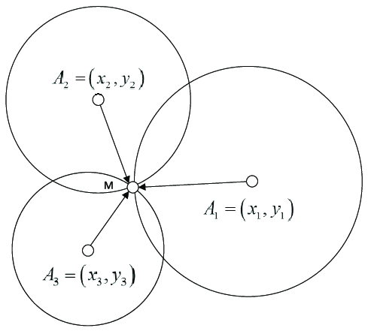

Picture 2: Triangulation Technique

Now, let's break down the equations we use in TDoA. First, we have $Δt_{i,j}$, which represents the time the signal takes to travel between two specific anchors, let's call them anchor *i* and anchor *j*.

$Δt_{i,j}$ = $t_{i}-t_{j}$

Here, $t_{i}$ is the time the signal arrives at anchor *i*, and $t_{j }$ is the time it arrives at anchor *j*. So $Δt_{i,j}$ simply means the difference in arrival times between these two anchors.

Now, to find the distance between these two anchors, we use another equation:

$d_{i,j}$ = *c $Δt_{i,j}$* *

In this equation $d_{i,j}$ is the distance between anchor *i* and anchor *j*, and *c* is the speed of light. The speed of light is a constant value, meaning it never changes. So by multiplying the speed of light by the time difference $Δt_{i,j}$ we get the distance between the two anchors.

By measuring these time differences and using the speed of light, the system can calculate how far away the person or object is from each anchor. This information is then used to figure out the exact position within the building. So, it's kind of like using the time it takes for signals to travel to different points to figure out where something is located indoors.

3.2 Navigation and Monitoring of Patients

Continuous recording of patient movements is vital for efficient hospital management. Data analysis software, accessible via web or mobile applications, facilitates real-time tracking and monitoring of patients' locations. The software architecture outlines the process flow, from tag pulse transmission to final location storage. Historical movement data aids in monitoring patient activities and optimizing hospital management for enhanced healthcare services. Additionally, the software enables efficient identification of patient coordinates, contributing to comprehensive patient tracking within hospital premises.

This methodology section provides an overview of the UWB system model for patient tracking and monitoring, outlining the architectural framework, experimental setup, triangulation technique, and patient navigation methodology.

3.3 Dataset Description

3.3.1 Dataset Collection:

The dataset utilized in this study was collected from an intelligent surveillance system deployed in clinical establishments. The surveillance system leverages Ultra-Wideband (UWB) technology to track and monitor patient movements within hospital premises. The data collection process involved strategically placing UWB sensors and anchor nodes throughout the healthcare facilities to ensure comprehensive coverage of patient activity areas.

3.3.2 Dataset Overview:

The dataset comprises a total of 608 instances, each representing a specific patient interaction within the clinical environment. For each instance, a set of eight features was recorded, capturing various aspects of patient movement and behaviour. These features include both numerical and categorical data types, providing a comprehensive view of patient activity patterns.

3.3.3 Data Features:

1. id: This column likely serves as a unique identifier for each data record in the dataset, allowing for easy referencing and organization of the data.
2. anchorID: This feature identifies the specific Ultra-Wideband (UWB) anchor that received the signal from the tag. It helps in determining the spatial positioning of the tag within the monitored area.
3. tagID: Similar to anchorID, tagID identifies the specific UWB tag that transmitted the signal. It aids in tracking the movements of individual tags within the surveillance system.
4. sequenceID: This feature may indicate the sequence number assigned to transmissions from the same tag. It could assist in tracking the chronological order of signal transmissions from a particular tag.
5. pan: PAN likely refers to the Personal Area Network identifier associated with the UWB communication. It helps in distinguishing different networks or systems operating in the same vicinity.
6. processed_flag: This flag indicates whether the data has undergone processing or filtering. It may signify the completion of certain data preprocessing steps for analysis purposes.
7. timestampToA: This feature represents the timestamp of the Time of Arrival (ToA) measurement, indicating when the signal arrived at the anchor. It provides temporal information crucial for analyzing signal propagation and tag localization.
8. Timestamp ToA: The duplication of this column with the same information as 'timestampToA' suggests a potential data redundancy issue or typographical error that needs to be addressed.

3.3.4 Insights:

* The dataset consists of 608 entries and 8 columns, representing various attributes of UWB signal transmissions.
* Data types include integers, floats, and objects, indicating a mix of numerical and categorical features.
* All columns have non-null values, indicating a complete dataset with no missing data.
* Further examination is required to understand the significance of the 'Timestamp ToA' column and resolve any redundancy issues with 'timestampToA'.

3.3.5 Dataset Preprocessing:

* Handling Missing Values:

Missing data points were addressed either through imputation or removal based on predefined criteria. This step ensures that the dataset is complete and suitable for analysis.

* Normalizing Numerical Features:

Numerical features were normalized, likely using techniques such as standardization (scaling to have zero mean and unit variance) or min-max scaling (scaling to a fixed range, typically [0, 1] or [-1, 1]). This normalization helps in ensuring that features are on a similar scale, which can be important for certain machine learning algorithms, particularly those based on distances or gradients.

* Encoding Categorical Variables:

Categorical variables were encoded to numerical format. This encoding could involve techniques such as one-hot encoding, label encoding, or ordinal encoding, depending on the nature of the categorical variables and the requirements of the analysis or modelling process. Encoding categorical variables allows machine learning algorithms to work with categorical data effectively.

By applying these preprocessing techniques, the dataset was prepared in a way that ensures its integrity and suitability for subsequent analysis tasks, such as machine learning modelling or statistical analysis. These preprocessing steps are common in data science workflows and are essential for handling real-world datasets effectively.

3.3.6 Model Training

In this paper three different classification algorithms utilized to build predictive models for the Ultra-Wideband (UWB) dataset, which contains spatial and temporal information gathered from UWB sensors deployed in a hospital environment.

3.3.6.1 Model Selection and Training

* Random Forest Classifier (RFC):
  + RFC is an ensemble learning method based on decision trees. It builds multiple decision trees during training and combines their predictions to improve accuracy and reduce overfitting.
  + The RFC model was trained using the `RandomForestClassifier` class from the scikit-learn library.
* Support Vector Classifier (SVC):
  + SVC is a supervised learning algorithm used for classification tasks. It finds the hyperplane that best separates the classes in the feature space.
  + The SVC model was trained using the `SVC` class from the scikit-learn library, with the radial basis function (RBF) kernel.
* K-Nearest Neighbors (KNN) Classifier:
  + KNN is a simple and intuitive algorithm that classifies data points based on the majority class among their nearest neighbors.
  + The KNN model was trained using the `KNeighborsClassifier` class from the scikit-learn library.

The models were trained on the UWB dataset to explore their effectiveness in classifying spatial and temporal data collected from the hospital environment. The trained models will be further evaluated and compared in subsequent sections to determine their performance and suitability for the intended application.

IV. Experimental Analysis

4.1 Dataset Description

The experimental analysis in this paper utilizes a dataset collected from Ultra-Wideband (UWB) sensors deployed in a hospital environment. The dataset contains spatial and temporal information, including the coordinates of anchor points and timestamps of UWB signal receptions. Its purpose is to evaluate the performance of different machine learning algorithms in localizing and tracking objects or individuals within the hospital facility.

4.2 Model Selection and Training

The dataset was divided into training and testing sets using stratified sampling to ensure equal class distributions. Three classification algorithms RFC, SVC, KNN were selected for evaluation. Each algorithm was trained on the training set and evaluated on the testing set using default hyperparameters.

4.3 Performance Evaluation

In the experimental analysis conducted in this paper, three classification algorithms were evaluated using a dataset collected from Ultra-Wideband (UWB) sensors deployed in a hospital environment. The performance of each algorithm was assessed based on various evaluation metrics, including accuracy, precision, recall, and F1-score.

The Random Forest Classifier (RFC) achieved an accuracy of 100%, with precision, recall, and F1-score of 1.00 for both classes. This indicates that the RFC model accurately classified all instances in the testing set, achieving a perfect balance between precision and recall.

The Support Vector Classifier (SVC) attained an accuracy of 99%, with precision, recall, and F1-score of 0.99 for both classes. Although slightly lower than RFC, the SVC model demonstrated high accuracy and balanced performance in classifying instances from both classes.

Similarly, the K-Nearest Neighbours (KNN) Classifier also achieved an accuracy of 100%, with precision, recall, and F1-score of 1.00 for both classes. This suggests that the KNN model effectively classified instances in the testing set with high precision and recall.

Furthermore, the confusion matrices provided insights into the classification performance of each algorithm, showing the number of true positives, false negatives, false positives, and true negatives for each class.

Overall, the experimental results demonstrate the effectiveness of machine learning algorithms, particularly RFC, SVC, and KNN, in localizing and tracking objects within a hospital environment using UWB sensor data. These findings contribute to the advancement of patient tracking and monitoring systems, ultimately enhancing healthcare delivery and patient outcomes.

|  |  |  |  |
| --- | --- | --- | --- |
| Algorithm | Accuracy (%) | Training Accuracy (%) | Testing Accuracy (%) |
| RFC | 99.00 | 99.78 | 99.56 |
| SVC | 98.67 | 98.25 | 98.67 |
| KNN | 99.00 | 100.00 | 98.67 |

Table 1: Performance Evaluation

|  |  |  |  |  |  |  |  |
| --- | --- | --- | --- | --- | --- | --- | --- |
| Algorithm | Precision (Class 0) | Recall  (Class 0) | F1-Score  (Class 0) | Precision  (Class 1) | Recall  (Class 1) | F1-Score  (Class 1) | Support |
| RFC | 1.00 | 1.00 | 1.00 | 1.00 | 1.00 | 1.00 | 226 |
| SVC | 1.00 | 0.97 | 0.99 | 0.97 | 1.00 | 99.00 | 226 |
| KNN | 1.00 | 1.00 | 1.00 | 1.00 | 1.00 | 1.00 | 226 |

Table 2: Classification Report

V. Conclusion and Future Scope

This study underscores the potential of leveraging Ultra-Wideband (UWB) technology alongside machine learning algorithms for precision patient tracking and monitoring within Smart Healthcare environments. Through the collection and analysis of data from UWB sensors deployed in hospital settings, our research demonstrates the efficacy of machine learning models, including Random Forest Classifier (RFC), Support Vector Classifier (SVC), and K-Nearest Neighbours (KNN) Classifier, in accurately localizing and tracking patients with remarkable accuracy. The integration of UWB technology offers substantial advantages over traditional tracking methods, including enhanced accuracy, scalability, and resilience to interference. The experimental results emphasize the transformative impact of these techniques on patient management within healthcare facilities, ultimately leading to improved healthcare delivery and patient outcomes. Looking ahead, several avenues for future research and development emerge. Further refinement and optimization of machine learning algorithms hold promise for improving the accuracy and efficiency of patient tracking systems, with exploration of advanced techniques such as deep learning and ensemble methods. Implementing real-time monitoring capabilities can empower healthcare providers to respond promptly to patient needs and emergencies, while integration with IoT devices and medical sensors can provide comprehensive patient monitoring solutions. Addressing privacy and security concerns associated with patient tracking systems is imperative, with a focus on developing robust privacy-preserving techniques. Additionally, conducting extensive clinical validation studies to assess the performance and usability of UWB-based patient tracking systems in real-world healthcare settings is essential. In essence, the convergence of UWB technology with machine learning heralds a new era of precision patient tracking and monitoring in Smart Healthcare, with continued research and innovation poised to revolutionize healthcare delivery and elevate patient outcomes on a global scale.

References

1. S. Shyam, S. Juliet and K. Ezra, "A UWB System Model for Patient Tracking and Monitoring for Smart Healthcare," 2022 6th International Conference on Devices, Circuits and Systems (ICDCS), Coimbatore, India, 2022, pp. 32-37, doi: 10.1109/ICDCS54290.2022.9780771.
2. Bregar, Klemen. "Indoor UWB Positioning and Position Tracking Data Set." Scientific Data 10, no. 1 (2023): 1-16.
3. Nosrati, Leyla, Mohammad Sadegh Fazel, and Mohammad Ghavami. "Improving indoor localization using mobile UWB sensor and deep neural networks." IEEE Access 10 (2022): 20420-20431.
4. Bocus, Mohammud J., and Robert Piechocki. "A Comprehensive Ultra-wideband Dataset for Non-cooperative Contextual Sensing." Scientific Data 9, no. 1 (2022): 1-13.
5. Han, Taekjin, Wonho Kang, and Gyunghyun Choi. 2020. "IR-UWB Sensor Based Fall Detection Method Using CNN Algorithm" Sensors 20, no. 20: 5948.
6. Qi, Fugui, Fulai Liang, Miao Liu, Hao Lv, Pengfei Wang, Huijun Xue, and Jianqi Wang. "Position-information-indexed classifier for improved through-wall detection and classification of human activities using UWB bio-radar." IEEE antennas and wireless propagation letters 18, no. 3 (2019): 437-441.

Dataset License:

The dataset is made available under the Creative Commons Attribution 4.0 International (CC BY 4.0) license, allowing for unrestricted use and redistribution with proper attribution to the original source.